Kum & Go’s New Marketplace Store Design Serves Up Safety, Beautifully
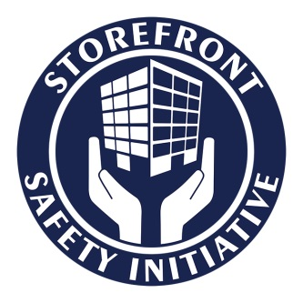
Iowa-based Kum & Go is widely regarded as one of the best run convenience store chains in the United States. It has expanded to more than 430 stores in 11 states, and has become the fifth largest company-operated convenience store chain in America.
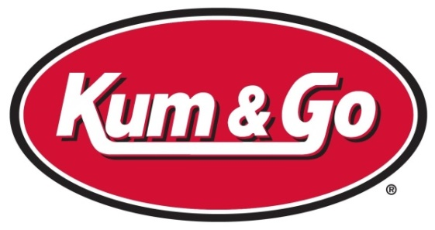
Operating 430 stores takes organization and continuous effort to grow sales and maintain profitability. But Kum & Go is not happy to just maintain – it is growing, with as many as 30 new or completely remodeled stores in the planning or construction phases. All but one of these new and rebuilt stores will be Marketplace stores, a proprietary design Kum & Go developed that meets rigorous standards of sustainability for the industry while setting new standards for the competition in terms of appearance, customer-orientation, and safety.
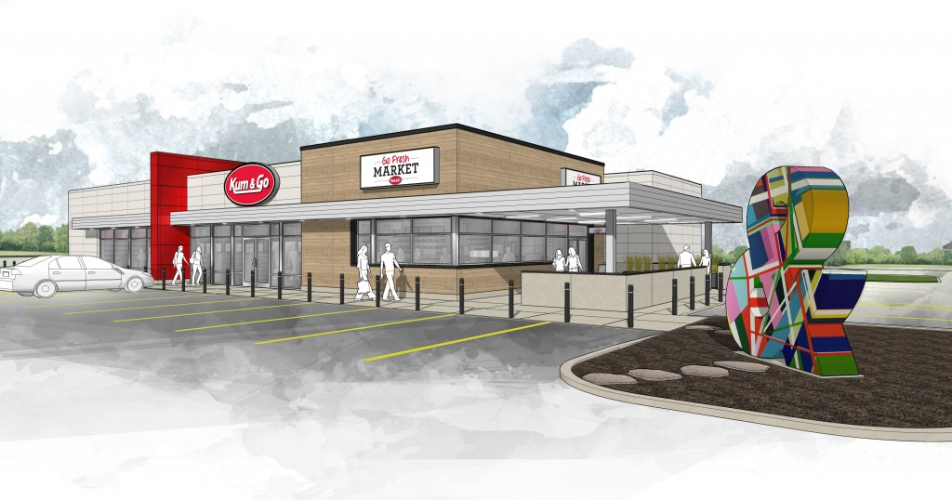

MARKETPLACE
At 6,200 square feet, the Marketplace design includes a larger footprint than most convenience stores, with substantially upgraded facilities that provide customers with fresh foods, on-premises kitchens, convenient seating, free Wi-Fi, and many other customer-friendly features. But the features that most stood out to us at the Storefront Safety Council were not just inside the store, but the storefront itself. Because we feel that the new Kum & Go Marketplace store design creates one of the most accessible and safest storefronts of any large chain in the convenience store industry, we decided to make Kum & Go our first Honored Participant of the Storefront Safety Initiative.
When we first contacted Kum & Go about their new Marketplace stores, we asked them why they had decided to “design in” safety and accessibility. The answer we got was immediate – safety, sustainability and customer convenience. It turns out that Kum & Go stores suffer about one vehicle incursion per month, and the company wanted to reduce the possibility of injuries to pedestrians, customers and employees. By redesigning the parking and pedestrian areas in front of the stores, Kum & Go was able to eliminate curbs and wheel stops so that customers moving from their vehicle to the store and back would be unlikely to encounter trip hazards or inconvenience.
These safety concepts were put forward internally at Kum & Go by Scott McGee, Director of Site Development & Construction in collaboration with Kristin Jarabek, Division Vice President. Their ideas and recommendations then went to Chris Jones, VP of Marketing and Mark Hasting, Chief Operating Officer of Kum & Go for final approval. Once approved, the team moved forward to standardize the elements of the Marketplace design.
“When Kum & Go developed the Marketplace store prototype, we took both curb appeal and safety into account. Our new Marketplace stores are not only a breakthrough in customer-focused design, but transformative in the way of storefront safety for Kum & Go.” Kristie Bell, Director of Communications, Kum & Go
Kum & Go sent the basic design out to retail branding experts CBX for work on store appearance, interior finishes, and signage, and to Kansas-based BRR Architecture for drawings, code compliance, and detailed construction plans for bidding and permits. BRR took the lead for the storefront from the team at Kum & Go and formalized the safety designs and features to make sure customers and employees were safe, all of the customer areas were ADA compliant, and the structure itself was sustainable and solid.
“From adequate lighting levels, considerations for pedestrians entering the store, and asset protection for the store and pumps, it was a priority for all involved to provide an environment that was safe and secure, and communicated these qualities to both customers and associates.” Mariah Meyer, AIA, LEED AP, Senior Associate, BRR Architecture
The end result is a customer-friendly store that looks very open, features a great many floor-to-ceiling windows, provides wide sidewalks, convenient parking, offers indoor and outdoor seating areas, and is safe and well-lit at night. One of the important design features that ties this together is the placement of steel bollards across the storefront to protect the sidewalks, windows, customers and pedestrians from vehicles that might fail to stop as they pull into park. Such incidents are common at locations with old-style parking lots or unprotected entrances, but Kum & Go mitigates this at Marketplace stores installing safety bollards to keep vehicles where they are supposed to be and separated from the storefront.
Kum & Go has invested time and resources to create a better looking and more successful store design, which they expect will be their standard for new construction and same-store remodels for some time to come. Attractive, friendly, sustainable and safe -- the Marketplace design sets a standard for the industry and earns Kum & Go the first Honored Participant award from the Storefront Safety Initiative.

